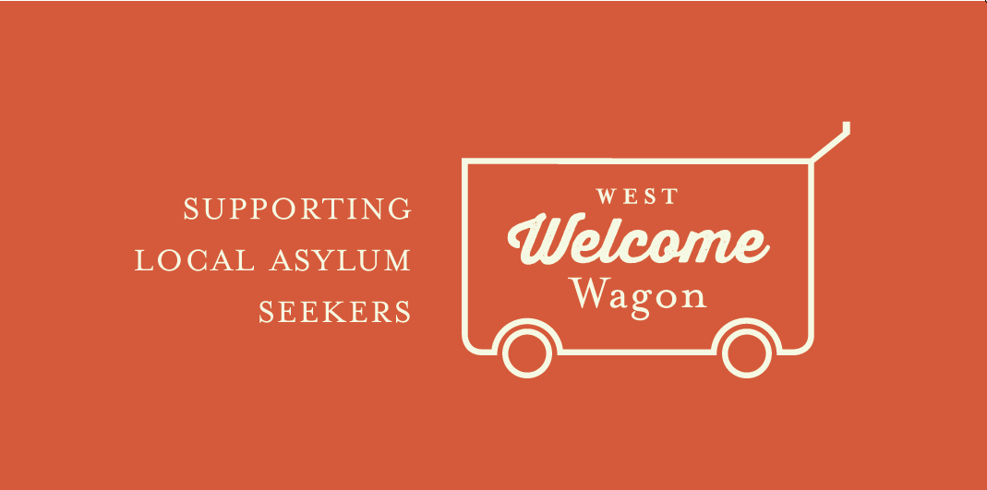
Donation Guidelines

At West Welcome Wagon, we strive to give only clean and quality items, free from breakages, blemishes, and stains. So whether you’re wanting to help out by giving kitchen items, children’s clothes, food or whitegoods, have a read of our guidelines so you know that your donation will be accepted by us, and appreciated by those who receive it.

Kitchen Items
Appliances: For safety reasons, it is imperative any appliances have been carefully checked and cleaned, are fully working, have no frayed cords or damage, and are less than 10 years old.

Our constantly most needed items include:
- Saucepans, fry pans, pots, oven trays, and cooking utensils
- Chopping boards and knife sets
- Juicers, blenders, meat grinders, pressure cookers, rice cookers, and kettles - with manufacturer's instructions
- Toasters and microwaves
- Plastic containers with lids (e.g. Tupperware)
- Canisters for tea, coffee and sugar
- Crockery sets (we can't accept mismatched items)
- Oven gloves and tea towels
- Colanders and strainers
- Spice racks
- Serving bowls, tea or coffee pots,
- Baking items
- Children's cutlery, ‘sippy’ cups, drinks bottles, plates and bowls
Unfortunately we do not have the capacity or the demand from asylum seekers for:
- bread makers,
- slow cookers
- novelty kitchen appliances (such as popcorn makers),
- espresso, shot, beer, or wine glasses, or champagne flutes
Chipped, cracked, dirty, stained and broken items are NOT accepted. If you do not have time to clean your kitchen goods before donating, it would be appreciated if you could please keep them or donate elsewhere.

Food and Household Items
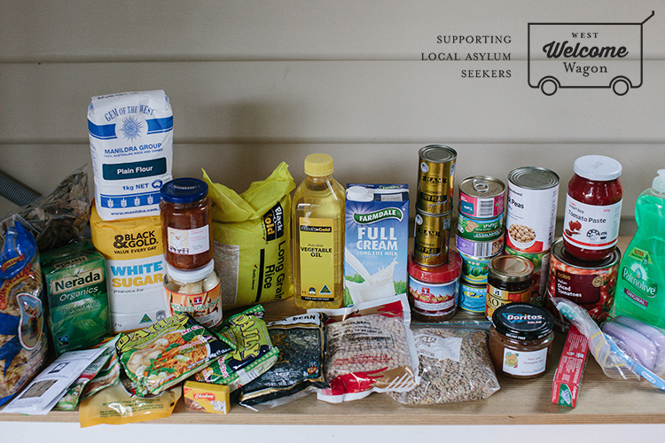

Items needed:
- Black/green tea, instant coffee
- Cereal
- Cooking oil – olive, canola, sunflower
- Dried red kidney beans
- Dried chickpeas and broad beans
- Flour – plain or self-raising
- Household cleaning items – washing powder (for top loaders), dishwashing liquid, cleaning cloths, toilet cleaner, floor cleaner
- Lentils – red, green and yellow (also known as daal)
- Pasta
- Rice – long grain or basmati
- Spices – salt, garlic, black pepper, chicken/fish stock cubes, paprika, coriander, cumin, turmeric, curry powder, basil, crushed chillies and ginger
- Spreads – jam, peanut butter, vegemite
- Sweet chilli sauce
- Tinned fish – tuna or salmon
- Tinned tomatoes, fruit and vegetables
- Toiletries – toothbrushes, toothpaste, soap, shampoo, conditioner, razors, deodorant
- Tomato paste
- Tomato sauce
- UHT milk
- White sugar

Children’s Items
We have stringent safety requirements for children's donations. Our priority as an organisation is to ensure the safety of all asylum seeker clients that we assist.
Car seats/capsules:
- Must have red safety standard sticker AS/NZS 1754.
- Must be under 8 years old.
- Date of manufacture should be printed on a sticker somewhere on the side or base of the seat.
- We do not take booster cushions.
- We cannot accept any seat that has been in a car accident.
- Please remove and wash the cover.
Highchairs and booster seats:
- Must have all restraint straps
- If it has wheels / castors they must lock
- Please take the time to ensure that entire chair is clean.
Prams and strollers:
- Must have all restraint straps
- Brakes and wheels must work
- Prams and strollers that lie back are preferred.
Cots/Portacots/Bassinettes:
- Must meet Standard AS/NZS 2172:2003 revised in 2005, must be manufactured after 2005
- Cot mattresses must be free of stains and rips. If donating a mattress by itself please provide the size as listed on the label.
- If donating a cot without a mattress, please provide the manufacturer's recommended mattress size which will be found stamped on the cot somewhere.
- If donating a cot please ensure you include the original assembly instructions and all parts (bolts, screws, etc) to assemble the cot
- Bassinets must have a properly fitting mattress.

