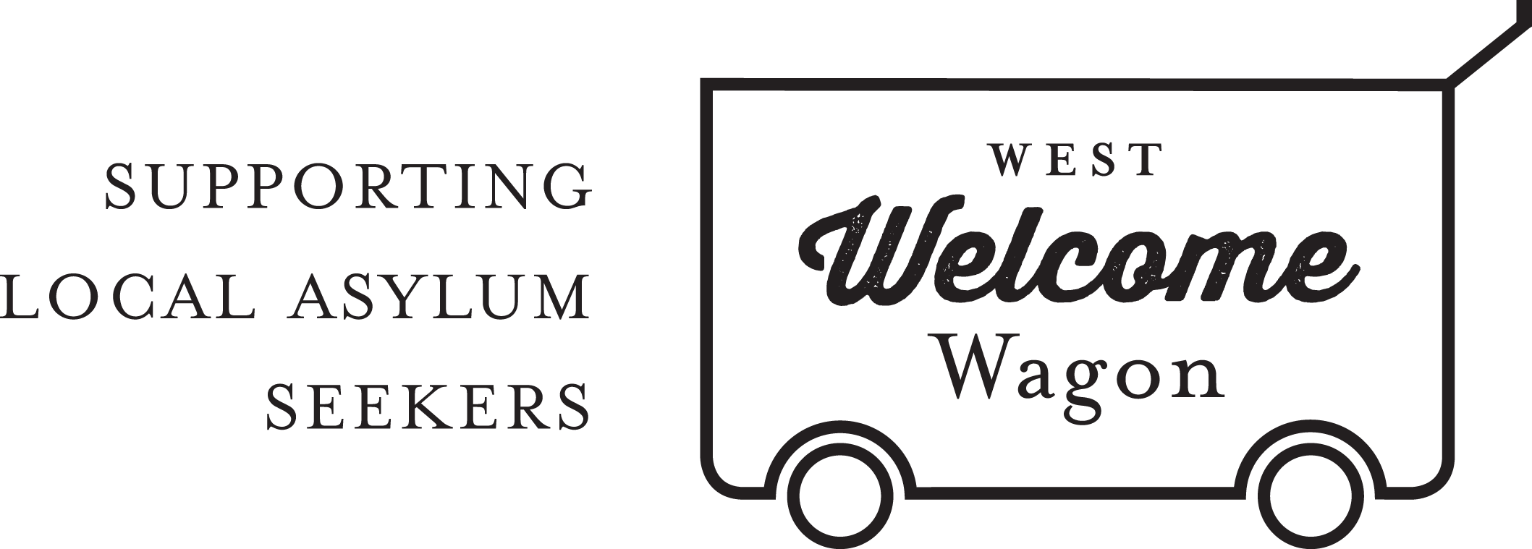
Events Coordinator
POSITION DESCRIPTION

West Welcome Wagon (WWW) is looking for someone to coordinate events and fundraisers, which usually take the form of sausage sizzles and information booths. These events generally occur on weekends as part of local festivals in the western suburbs of Melbourne, or at other events where WWW has been invited to participate. The events are an important opportunity to raise funds to support the work of WWW, reach out to community members and grow the organisation’s profile. Most events are supported by a team of 8-15 volunteers allocated by a roster.
The coordinator is not expected to attend all events, but will coordinate the necessary activities for the day and delegate the lead role to other volunteers.

Tasks:
- Establish and coordinate a calendar of events planned;
- Liaise with members of the Fundraising and Community Engagement teams to plan the events;
- Callout to volunteers via Facebook;
- Setting up sausage sizzles, including buying produce for sale, collecting and transporting the BBQ, marquee and trestle table, setting up and packing up, cooking sausages, serving customers and taking care of cash transacted on the day;
- Organise a social event for the West Welcome Wagon volunteers on a six monthly basis.

Requirements:
- Facebook literacy;
- Availability to attend occasional events, usually on weekends;
- Excellent communication skills, especially for dealing with members of the public;
- Organisation skills.
- Ability to represent West Welcome Wagon in a positive manner;
- Desirable: access to a vehicle to transport food and equipment to and from events.

West Welcome Wagon will provide:
- Ongoing support from the Business Development Manager, Human Resources and the CORE group of volunteers;
- Funds to purchase supplies needed for BBQs, stall displays and other events as relevant;

For more information, please contact volunteer@westwelcomewagon.org.au.

