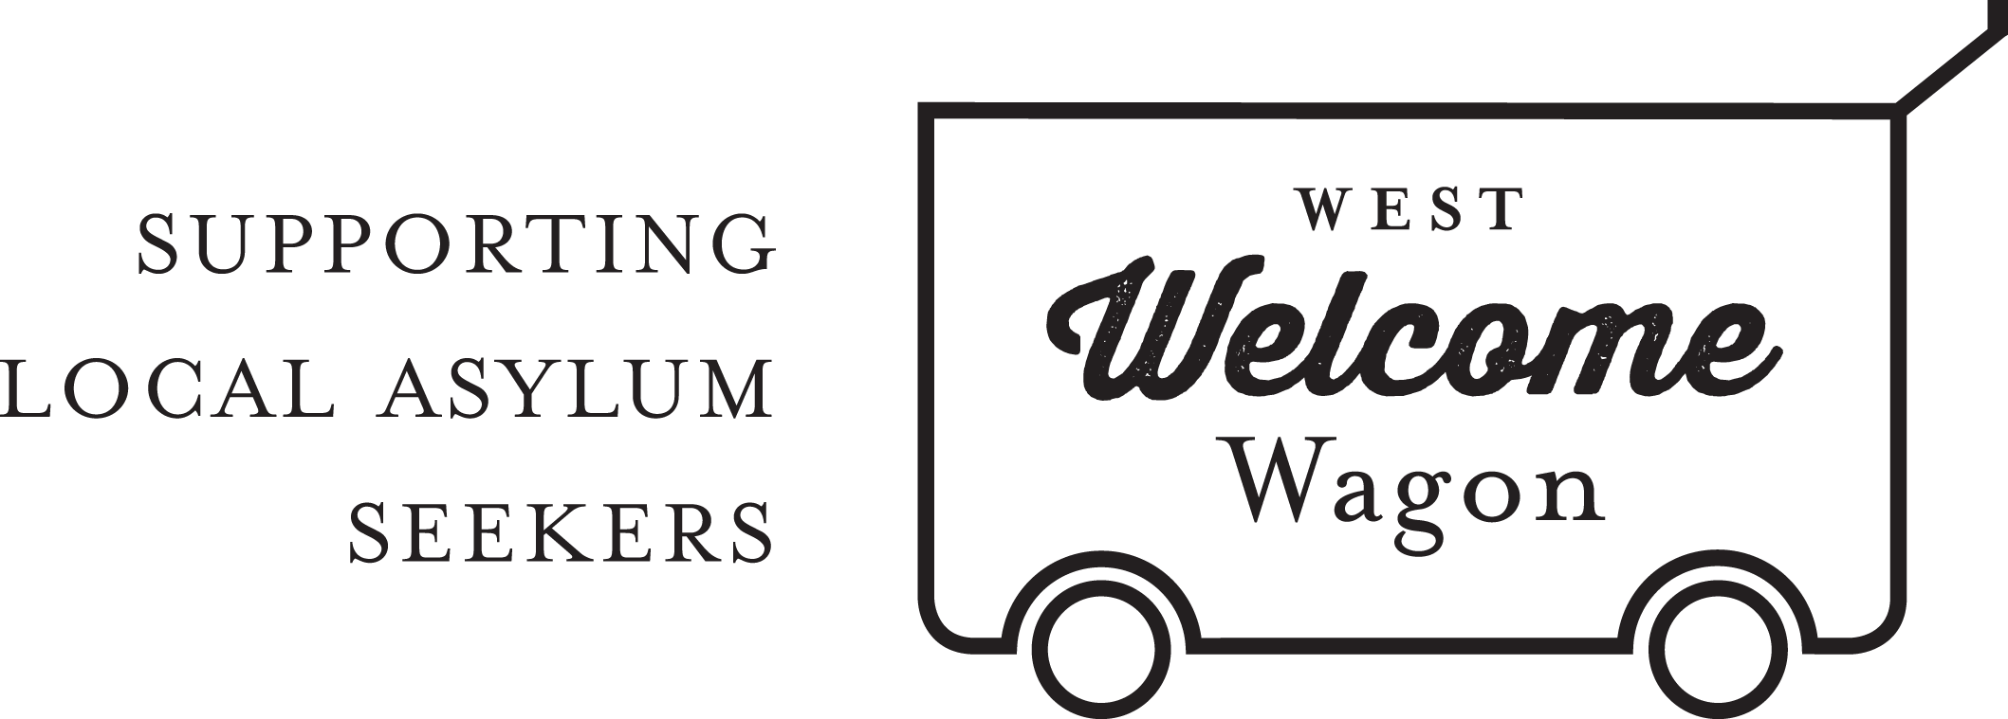
WWW PARTNERSHIP COORDINATOR
POSITION DESCRIPTION

The Partnership role for West Welcome Wagon (WWW) reports to the Business Development Manager and is responsible for finding and managing sponsors.

This is a volunteer position. Work will generally be done from the volunteer’s own home and at times to suit the volunteer. It is expected that this volunteer role requires a time commitment of approximately 4 hours per week.

Key Tasks and Activities:

- Solicit businesses and other organisations to sponsor West Welcome Wagon
- Creating and executing marketing and sales plans
- Create partnership proposals for prospect
- Collaborating with other departments
- Arrange meetings with interested partner prospects
- Design and coordinate advertising materials and events for partners
- Sell partnership
- Manage partner expectations
- Negotiate partnerships and review all deals. Secure approval for any departures from pre-approved rights and benefits

Selection Criteria:

- Possess strong written and verbal communication skills along with a strong, persuasive personality
- Need to be professional, friendly, organised, energetic and determined in attempting to land sponsors
- High-level experience in sourcing new partners
- Servicing existing partners and developing other revenue streams
- Ability to build a rapport with partners quickly
- In-depth understanding of the partnership industry
- High level of attention to detail
- Strong organisational skills
- Excellent IT skills

West Welcome Wagon will provide:
- Ongoing support from the Business Development Manager, Board, members of the Business Development team and the CORE group of volunteers.
- A small budget may be available if needed, with the understanding that any expenditure must be budgeted for and expenditure reports prepared for the CEO and Board as required.
- Volunteer experience with a grass-roots asylum seeker support organisation
- Regular social events with the team of WWW volunteers.

