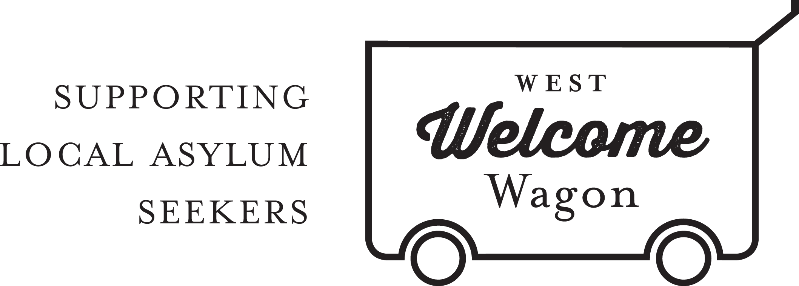
WWW Human Resources Manager
POSITION DESCRIPTION

The Human Resources Manager for West Welcome Wagon (WWW) reports to the CEO and is responsible for ensuring WWW has sufficient suitable volunteers and staff to carry out its functions.This position is on the management team of the organisation.

This is a volunteer position. Work will generally be done from the volunteer’s own home and at times to suit the volunteer. It is expected that this volunteer role requires a time commitment of approximately 6 hours per week.

Key Tasks and Activities:
- Develop and implement strategies to ensure WWW is able to recruit sufficient volunteers.
- In conjunction with the other WWW managers, ensure that new volunteers are matched to suitable roles within the organisation.
- Maintain Position Descriptions for the various roles within WWW.
- Oversee the induction and training of new and existing volunteers and staff.
- Develop strategies to ensure high levels of volunteer retention.
- Ensure WWW staff are employed under appropriate terms and conditions, and that WWW is meeting its obligations regarding its employees.
- Evaluate HR policies and make recommendations to the Board for changes as appropriate.
- Recruit and manage a HR team to ensure the objectives of the HR department are met.
- Provide regular reports on the activities and progress of HR strategies to the CEO and management team.

Selection Criteria:
- Professional qualifications, or equivalent experience in Human Resources management
- Excellent communication style, and the ability to work online and manage a small team remotely
- Strategic thinking and conflict resolution skills
- Facebook, Google Drive and HR database management skills.

West Welcome Wagon will provide:
- Ongoing support from the CEO, Board, members of the management team and the CORE group of volunteers.
- A small budget may be available, with the understanding that any expenditure must be budgeted for and expenditure reports prepared for the CEO and Board as required.
- Volunteer experience with a grass-roots asylum seeker support organisation

For more information, please contact Roland at volunteer@westwelcomewagon.org.au.

