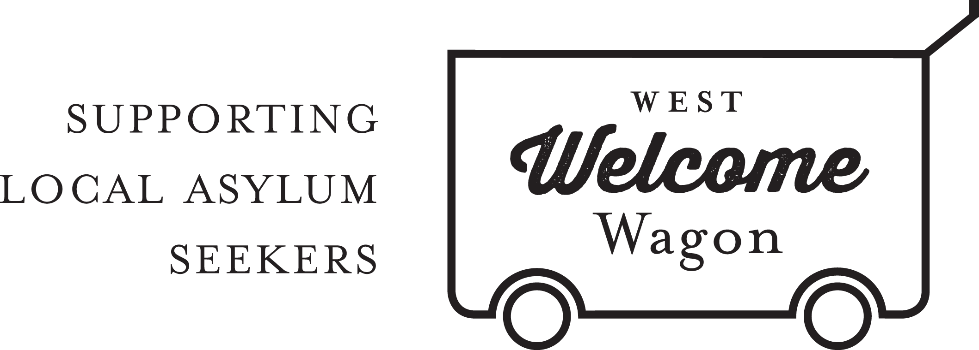
WWW Policy and Compliance Manager
POSITION DESCRIPTION

The Policy and Compliance Manager for West Welcome Wagon (WWW) will be managing a team of core volunteers to develop and maintain important policies and procedures for the effective governance of WWW. The role reports to the CEO.

This is a volunteer position. Work will generally be done from the volunteer’s own home and at times to suit the volunteer. We estimate the role requires the Manager to be available for approximately 4 hours per week.

West Welcome Wagon (WWW) became incorporated in September 2014. As a not-for-profit organisation we are responsible for the actions and protection of our volunteers.

Requirements:
- Facebook and Google Drive literacy – excellent communication style, and ability to work online managing the small team.
- Working to develop and maintain relationships with legal information and advice providers.
- Experience in policy and compliance, or legal position will be highly regarded.

Main Tasks and Responsibilities of the Manager:
- Development and execution of policies and procedures that manage and oversee the work of core volunteers.
- Organisation and Team execution of developing department goals, objectives and systems.
- Working with the other departments of WWW to ensure consistency across legal requirements, training and compliance issues.
- Further development of the Policy and Compliance team for WWW and assigning roles to skills needed.
- Provide regular reports to the CEO on these activities and progress of the Team, as well as attending occasional Board-Management meetings (approx. every two months).

West Welcome Wagon will provide:
- Ongoing support from the CEO, other Managers, the Board, and the CORE group of volunteers.
- Freedom to develop the Policy and Compliance Team according to skills required.
- A small budget to use at will for Policy and Compliance needs, with the proviso that you will be accountable for the funds use, and will be required to report to the CEO on this expenditure.

For more information, please contact volunteer@westwelcomewagon.org.au

