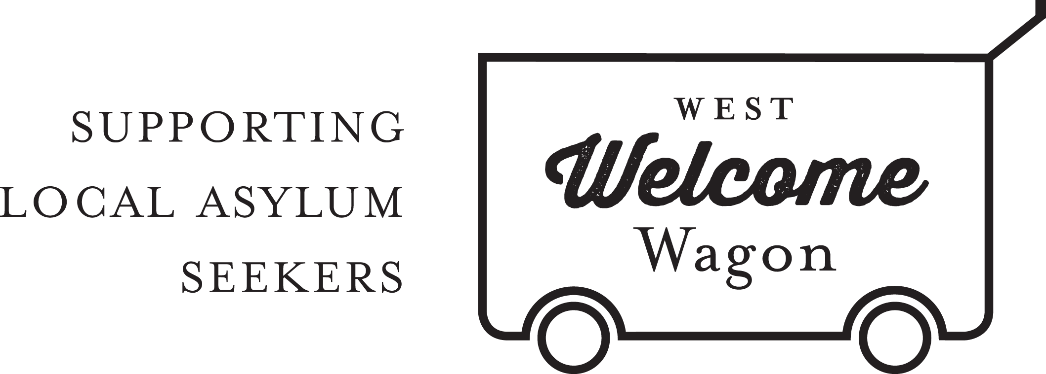
WWW SMALL GOODS COORDINATOR
POSITION DESCRIPTION

The Small Good Coordinator for West Welcome Wagon (WWW) reports to the CEO and is responsible for the coordination of small goods deliveries.

This is a volunteer position. Work will mostly be done from the volunteer’s own home and at times to suit the volunteer however some operational responsibilities will need to be performed at the WWW Warehouse in Sunshine West. It is expected that this volunteer role requires a time commitment of approximately 4-8 hours per week.

Key Tasks and Activities:
- Overseeing what deliveries are required in accordance with advice from team members of the Facebook group or alternatively based on existing stock in warehouse.
- Updating Facebook with information on unallocated deliveries.
- Allocating deliveries to available volunteers.
- Responsibility for updating the database with information about deliveries as the need arises.

Selection Criteria:
- Demonstrated excellent organisational skills, particularly in a practical setting.
- Ability to multitask and coordinate various streams of information in a timely manner.
- Ability to work online managing a small team.
- Facebook and Google Drive literacy

West Welcome Wagon will provide:
- Ongoing support from the CEO, Warehouse Manager, Board, members of the Small Goods team and the CORE group of volunteers.
- Volunteer experience with a grass-roots asylum seeker support organisation
- Regular social events with the team of WWW volunteers.

For more information, please contact the HR Team Volunteers at volunteer@westwelcomewagon.org.au.

