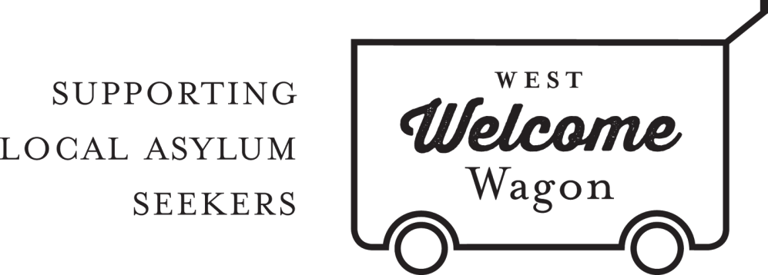

Toy Coordinator
POSITION DESCRIPTION

The Toy Coordinator accepts, cleans, sorts and coordinates distribution of toy donations and books for asylum seeker homes supported by West Welcome Wagon (WWW).

This is a volunteer position. We estimate the role will require the Coordinator to have approximately 6-8 hours available to volunteer per week.

Main tasks and responsibilities:
- Receive donations;
- Sort by age and clean as required (assistance is available for this via volunteers);
- Ensure toys are safe for young children (remove all batteries and small parts);
- Store toys and make packs as required;
- Notify Delivery Coordinator when toy packs are ready to be distributed;
- Work with the Delivery Administrator, who monitors the database of requests for items and donations, as well as the Facebook page where donations are posted.

Requirements:
- Facebook and Google Drive literacy, as the majority of communication and organisation is undertaken this way;
- Communication skills, particularly in online communication;
- Organisational skills for keeping track of donations coming in and out;
- An understanding of WWW's work and goals;

West Welcome Wagon will provide:
- Induction into the organisation and the role;
- A volunteer to undertake administration for the role;
- Ongoing support from the Committee, Operations Manager, and the CORE group of volunteers;
- Regular social events with the team of WWW collectors and organisers.
For more information and how to apply, please contact volunteer@westwelcomewagon.org.au.

