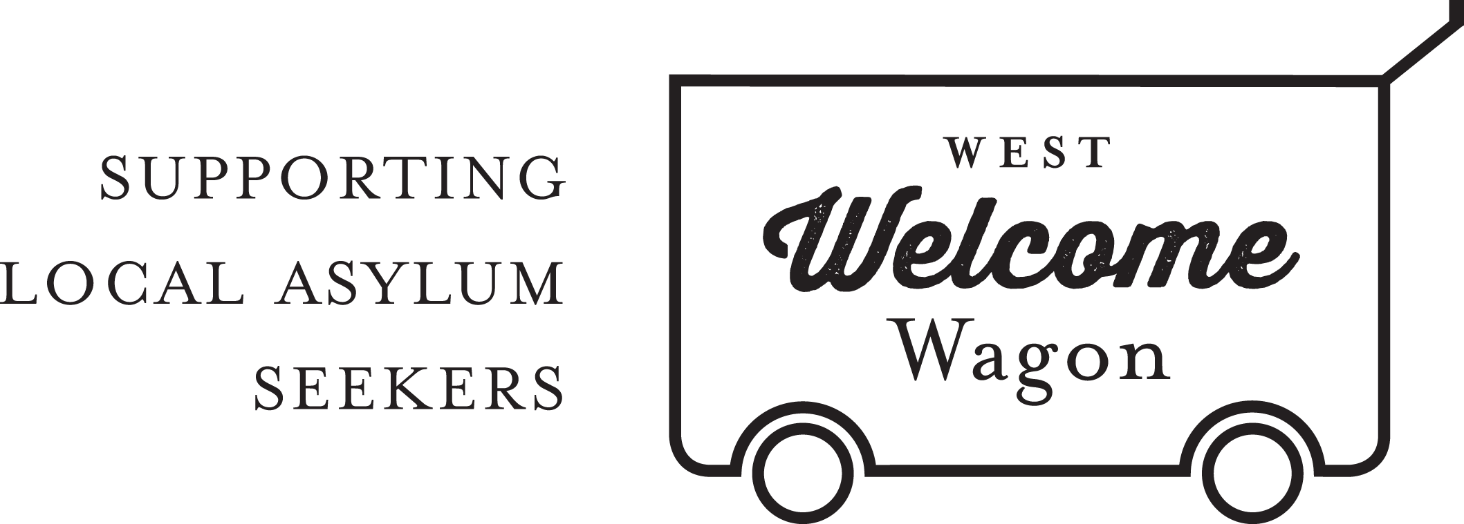
WWW Warehouse Coordinator
POSITION DESCRIPTION

The Warehouse Coordinator for West Welcome Wagon (WWW) will be coordinating a team of core volunteers to deliver material aid from WWW’s warehouse in Sunshine West to WWW client’s across Melbourne’s western suburbs. The role entails management and maintenance of the WWW warehouse as well as coordination of the large goods team.

This is a paid position for 16 hours a week on a 6 month contract. Work will primarily be done from the WWW Warehouse in Sunshine West, though the employee may be required to respond to online requests via Facebook and/or emails. This role reports to the CEO.

West Welcome Wagon (WWW) became incorporated in September 2014. As a not-for-profit organisation we are responsible for the actions and protection of our volunteers.

Requirements:
- Volunteer agreement signed
- A current and valid working with children check
- Good spreadsheeting and database management skills
- Facebook and Google Drive literacy
- Excellent communication style, and ability to work online and face to face managing volunteer team.
- Expertise in warehouse management procedures and best practices
- Leadership skills and ability manage volunteers
- Strong decision making and problem solving skills
- Experience in WH&S would be highly regarded

Main Tasks and Responsibilities of the Coordinator
- Oversee receiving and warehousing of goods
- Plan the delivery of goods to clients
- Keep the stock and despatch database updated
- Liaise with clients, donors, and suppliers
- Work closely with other WWW teams, particularly the referrals and assessment teams
- Ensure efficient space utilization in the warehouse
- Manage and report on stock levels
- Prepare annual budget (in coordination with CEO)
- Reporting and responsibility for budget allowance.
- Maintain standards of health and safety, hygiene and security
- Train volunteers on OH&S practices
- Run inductions for the warehouse and large goods team

West Welcome Wagon will provide:
- Ongoing support from Managers, the CEO, the Board, and the CORE group of volunteers.
- Training where applicable
- A budget to use at will for Warehouse operational costs, with the proviso that you will be accountable for the funds use, and will be required to report to the CEO on this expenditure

For more information, please contact volunteer@westwelcomewagon.org.au.

